Find the Address(1d)

As we mentioned if variable store a integer array that holds the 1000 records if it started with 1000 address it increase by 2 if the record is to huge it is difficult to find the address .

For this , if we need to find the specific element address of the array we use some formula to get that .

If we have any 1d array we use to find the random access it is easy to get that

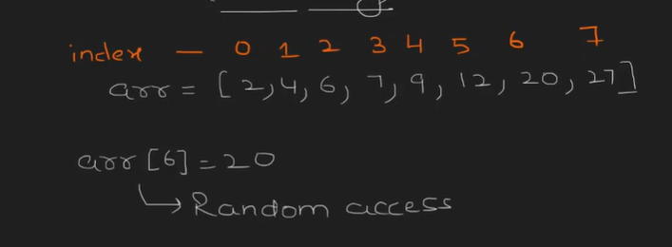

This is we called as a Random Access

If we want to find the random index location(address)

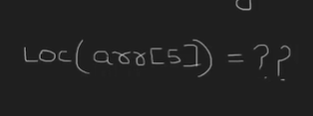

Base Address is 1000

Formula 🡪Base Address + (m –l) \* size of the dtype

This Formula Applies For One Dimensional Array

Base Address + (array [index] – start of the array index) \* size of the datatype

If we see our case

1. Base Address = 1000
2. Array [index] to find = 5
3. Start of the array index = 0
4. Datatype size (int) = 2

If we substitute :

1000 + (5-0)\*2

The Answer is 🡪 1000+ 10 🡺 1010

1010 is the Address of the 5th index

Problem 2 :

If our array index start with -150 and end with 500

Lower bound 🡺 -150

Upper Bound 🡺 500

And the base Address is 0 and the dtypes is 5bytes

To find the location of 350

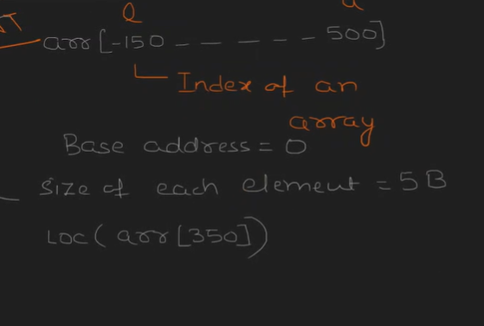

Formula is :

Base Address + (m –l) \* size of the dtype

1. + (350 +150)\*5

* 2500 is the Address of 350 index as per your concept

Problem 3 :

Array start index is 25 and end at 150

Base address 500

Size 10 bytes

Find out 78

Formula is :

Base Address + (m –l) \* size of the dtype

500 + (25 – 78) \* 10

500 + (-53) \* 10

500 + (-530)

-30

The Address is -30 for location 78